A differential operation principle of the automatic bus transfer system pickup unit as a way of decreasing the emergency clearing time.a
Nikolay Danilov¹,Sergey Tsyruk¹, Alexandr Timonin¹ and Karam Sharafeddine^{1,2}

¹ Moscow Power Engineering Institute, Moscow, Russian Federation
² Lebanese University,Beirut, Lebanon

Abstract. A proper choice of the design and operation algorithm of emergency control devices like high-speed bus transfer (HSBT) is only possible proceeding from a study and analysis of steady-state and transient processes in emergency modes of operation (short-circuit faults, power supply disconnection, or phase open-circuit fault). The numerical experiments for studying such modes that were carried out, using the Matlab Simulink software package, on the mathematical models of an industrial power supply system involving synchronous motors connected to it made it possible to synthesize a new differential HSBT pickup unit featuring a high-speed response to emergency events. In doing so, special attention was paid to an analysis of transient operation modes with the aim of minimizing the probability of false actuations. The obtained study results have found practical application in the HSBT devices installed at the facilities of PJSC MOSENERGO. The experience gained from the operation of a new device jointly with high-speed circuit breakers produced by the Tavrida-Elektrik state-owned corporation has demonstrated essential advantages in comparison with the conventional HSBT designs.
- Introduction
The choice of the design of emergency control devices like fast bus transfer (FBT) arrangements for redundant power supply systems is primarily connected with the need to retain transient stability of synchronous motor load within the time interval taken to isolate an emergency and restore normal power supply.
The possibility of retaining the transient stability is determined by a certain limit time T_{crit} for which the synchronous motor (SM) load angle δ (Fig. 1a) [1] in the case of loss of power supply does not reach the critical value δ_{crit}, above which the motor’s rotor will slip, thereby aggravating the resynchronization process (Fig. 1b).
The values of T_{crit} and δ_{crit} depend on the power supply system configuration and parameters, kind of emergency (short-circuit faults, tripping the input circuit breaker by relay protection, etc.), and also on the electric motor operation parameters (capacity utilization factor CUF and power factor cosφ) [2].
The conventional FBT arrangements are not used almost at all at enterprises having a continuous process cycle, including trunk pipeline transport, petrochemistry, etc. in view of their insufficient
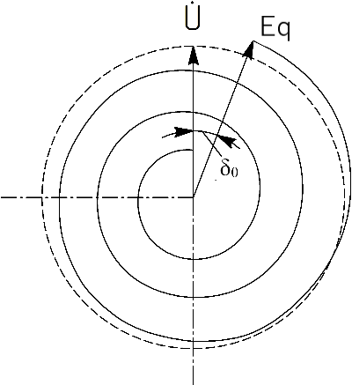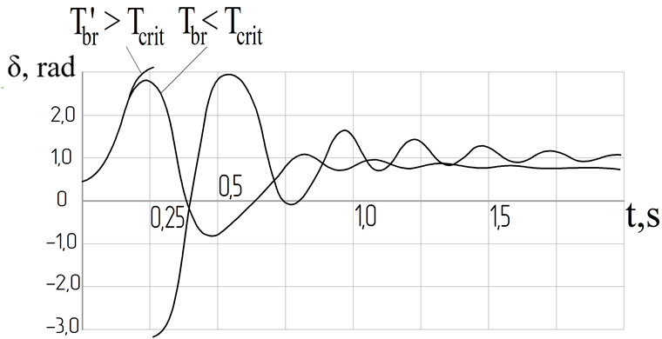
(а) (b)
Figure 1. Variation of the synchronous motor EMF Eq and angle δ in the case of loss of power supply (a) and synchronous motor resynchronization after power supply restoration (b).
operation cycle time equal to 30-40 ms has been developed, although---given the constantly increasing capacity of single electrical appliances and their high sensitivity to the power interruption time---even these operation times are criticized [3].
In redundant power supply systems that contain HSBT devices (Fig. 2), the total time taken to isolate emergencies is determined from the expression
T_{int} = t_{HSBT} + t_{icb} + t_{tcb},
where t_{HSBT} is the HSBT response time; t_{icb} is the input circuit breaker opening time, and t_{tcb} is the tie circuit breaker closing time.

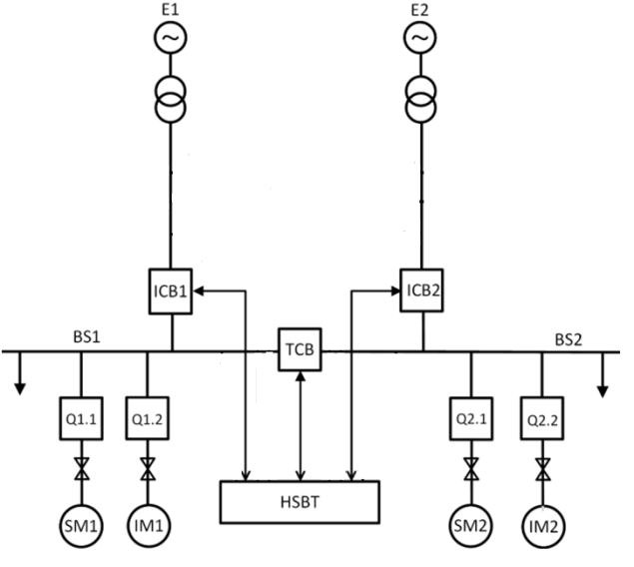
Figure 2. Typical power supply scheme with two independent inputs and two busbar sections.
The operation of circuit breakers accounts for the major part of the time in the HSBT cycle; improvement of their response speed can hardly be expected in view of potential switching over voltages and extremely high mechanical loads in their contact parts [4, 5]. In the HSBT algorithm, a shift is possible from the sequential command generation scenario [6], in which the commands for opening the input circuit breaker (ICB) and closing the tie circuit breaker (TCB) are produced simultaneously. This allows the HSBT cycle time to be decreased by 35-40% on the average. However, the statistics gained in the course of HSBT operation shows that improvement of the overall response speed entails a higher percentage of device false actuations, which points to an insufficiently mature structure of automatic controls and their operation algorithms.
The article studies the regularities and parameters characterizing the transients in power supply systems, based on which new principles for detecting the occurrence of emergencies are proposed. As an outcome, along with better HSBT response speed, the reliability of commands for device actuation has been improved.
- Statement of the problem
An emergency at the switchgear input can be detected by using the following criteria:
- the input voltage is not in line with the required level;
- there is a deviation of the monitored input voltage frequency or phase;
- there are over currents in the load circuits;
- there are excessive levels of negative- or zero sequence voltages;
- the power flow changes its direction for the opposite.
The above-listed criteria are interrelated in some or other way, which adds some complexity to the analysis of operation parameters, because some of them are both enabling and disabling in nature. For example, a dip of input voltage may be a consequence of a short circuit fault both at the input and in the load circuits; however, in the second case the HSBT pickup unit must remain silent. As a second example, consider a situation in which a dip of input voltage occurred, but the value of zero sequence voltage exceeded its setpoint. On the one hand, it can be considered that the HSBT pickup unit should remain silent because there is a disabling 3U₀ signal, but on the other hand, this situation may be a consequence of an open-circuit fault of one or two phases at the input, and a fast switchover to the standby power source must be carried out.
Let us find the response time of the HSBT pickup unit for the case of the HSBT conventional design [7]. We assume that the logical device controlling the pickup unit operation receives, in a real time mode, a continuous flow of discrete data characterizing the operating parameters. The initial values of operating parameters are periodic functions of time; therefore, for performing a fully valued analysis of each of the above-listed criteria, the time interval T = 1/F_{n} (F_{n} = 50 Hz is the network frequency) is theoretically necessary; this interval is a “sliding window” [8], in which the sequence of stored data “moves” in time and is constantly updated with new values.
The parameter T will appear in each analytical expression for calculation of the effective and mean values, for the signal power, and for the frequency and phase. The frequency is calculated by analyzing discrete samples in the interval Т = 1/F_{n}. For calculating the phase, the discrete Fourier transform (DFT) is used, in which the sampling frequency is selected so that the ratio N = F_{s}/F_{n} (where F_{s} is the sampling frequency) is always an integer number. In our case, N is the “window” size the value of which will be a multiple of the network frequency F_{n}. The expressions for calculating the above-mentioned parameters can be presented as follows:
The effective voltage value for the cycle:
(1)
The mean voltage value for the half-cycle:
(2)
The mean power (the analytical expression):
(3)

The mean power (for discrete systems):
 | (3)
 | (4)
DFT: | (5)
where k = 0…N-1, N = F_{s}/F_{n}.
It should be noted that in contrast to the other parameters, the mean power is calculated by a factor of two faster, because formula (3) for calculating it contains the cosine of a double argument, which in certain situations involving predominantly motor load makes it possible to achieve a factor of two higher response speed. In some operation modes, the algorithm response speed can be increased by shifting the actuation setpoint closer to the normal operation mode. In this case, however, it is obvious that as a result of narrowing the relay hysteresis loop, the use of such method may lead to unexpected actuations under normal network operation conditions. Thus, in the conventional systems the HSBT response speed cannot be increased without additional processing of the monitored signals.
- The pickup unit differential operation principle
Before to consider the differential pickup unit [9] in detail, the following note should be made: a step change of the frequency or phase is a mathematical abstraction, because in reality in digital devices these quantities are always calculated inside the “sliding window”; therefore, they vary quite smoothly within the interval Т = 1/F_{n}. Thus, for example, the system will “see” a step change of the voltage phase only when this fragment of digital sequence will fully turn to be in the data window, i.e., in N cycles after the event onset (Fig. 3). In the case of a step frequency change, all samples relating to the previous mode must leave the data window, which is also possible in N cycles (here and henceforth, the following values were chosen as input data: F_{s} = 2400 Hz, and N = 48).
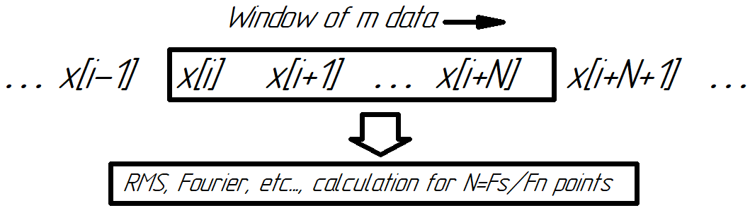

Figure 3. Calculation using the “sliding window” method (F_{s} is the sampling frequency, and F_{n} is the network frequency).
For revealing step changes in the function being studied, the analysis of the effective (RMS) value in the interval T can be replaced by comparison of the current quantity with a reference function taken from the preceding or earlier cycles. This operation is similar in its sense to differentiation, but is simpler to implement in comparison with it and is free from uncertainties at the discontinuity points of the function being analyzed. The output signal produced by the pickup unit constructed in this manner is proportional to the input signal variation rate and is effective only for detecting fast changes at the device inlet. With such an arrangement, the response time for discrete signals corresponds to one sampling step. For signals having a comparatively slow variation rate (with respect to their previous valued in the interval T), the pickup unit effectiveness decreases proportionally; therefore, it is better to analyze these signals using the conventional methods. Thus, it can be concluded that a pickup unit that complies with all conditions in terms of response speed and emergency detection efficiency should in our opinion have, by analogy with PID automatic control [10, 11], the integral-differential structure shown in Fig. 4.
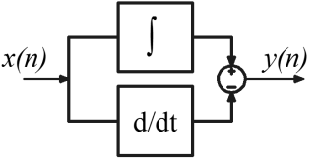

Figure 4. Structure of the integral-differential pickup unit.
In should be borne in mind that unnecessarily high response speed of the pickup unit may result in undesirable actuations when short-term voltage dips occur, which do not have an essential influence on the power supply quality. Thus, if the pickup unit comes in action in response to a 1.5-ms long voltage dip, this may result in a power supply interruption with the duration t ≥ 12 ms depending on the types of the used circuit breakers and control method [12]. Therefore, to decrease false actuations, we will consider the revealed faults with the duration t_{f} ≤ 2 ms as interference, and the other faults will be regarded as potentially hazardous from the viewpoint of the possibility to evolve into a real emergency [1].
Instrument current transformers (CTs) and voltage transformers (VTs) serve as data sources for the HSBT system. It should be borne in mind that instrument transformers provide the specified accuracy class only for steady state values. In transient modes, the instrument transformer behavior is not standardized as a consequence of the nonlinear properties of the transformer steel under the nonzero pre-emergency mode conditions. If a nonzero current flow through the CT primary winding, the transformer will store the following energy in each half-cycle:
(6)
where is the magnetization inductance, and is the magnetization current amplitude?
If the current in the primary circuit is abruptly disconnected at the time moment with E ≠ 0, the current through the transformer secondary winding will not become zero until the transformer energy stored in the previous cycle is fully transferred. If an inrush current occurs, the current increase rate in the CT secondary winding will be determined by the leakage inductances L_{s}1, L_{s}2 of the CT equivalent circuit, which in turn depend on the CT design features.
Voltage transformers may physically consist of several interconnected single-phase transformers or a combination of a three-leg E-type transformer and a single-leg shell-type transformer. Besides, anti-resonance-type VTs include additional zero-sequence transformers (ZSTs), which may have various parameters of their magnetic system depending on the particular design version. Situations should be considered for VTs when one or two phase voltages disappear in the network. In this case, a mode similar to a single-phase ground fault (SPGF) with a simultaneous occurrence of a zero sequence voltage U₀ across the VT open delta occurs. The voltage at the open delta output is given by the following expression:
(7)
where ,, are the reduced phase voltage vectors.
With a deep voltage dip [13], e.g., in the C phase (), in accordance with (7) and the cosine theorem, at the open delta output we obtain
(8)
where U is the effective value of the reduced phase voltage.
Since the phase voltage at the instrument VT input is always reduced to the value , at any phase voltage dip moment, we obtain across the VT open delta the value V. From (7) it follows that the same voltage appears at the above-mentioned output when two phase voltages disappear simultaneously. For finding the output voltage in the case of a SPGF of any phase, in (8) we substitute, instead of phase voltages, line-to-line voltages with the angle =60⁰, as a result of which we obtainV.
This example shows the following:
- the transient triggered as a consequence of a dip of any phase voltage will depend on the pre-emergency mode and also on the type and internal parameters of the used VT;
- any imbalance of the input voltages after completion of the transient in the VT results in the occurrence of the zero sequence voltage U₀, which can be mistakenly interpreted as an SPGF.
In view of the reasoning presented above, the data obtained from instrument transformers for 1-2 ms from the transient onset moment should be regarded as unreliable; otherwise, this may provoke false operation of the pickup unit. Besides, for correct operation of the pickup unit, the SPGF mode recording setpoint should be above 100/3 V.
- Numerical experiments and validation of the results
For checking how correctly the HSBT control algorithm operates in emergencies differing from one another in the kind and occurrence place, a pickup unit analysis mathematical model was developed, which was implemented in the Matlab (Simulink) environment [14] (Fig. 5).

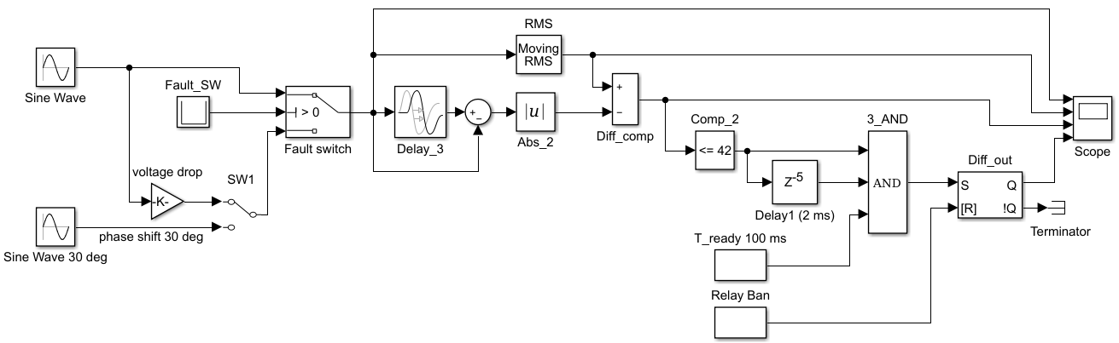

Figure 5. Differential pickup unit analysis model.
For analyzing the model behavior, the following disturbances are applied to its input: in the first case, it is a sinusoidal signal 60 sin(ωt) with its amplitude decreased by a factor of two at the time moment 0.155 ms, and in the second case, a step change of the phase by 30° occurs in the input signal under the same conditions. The input signal type is selected by means of the SW1 switch. The actuation threshold in response to the minimal voltage is set equal to 30% of the nominal phase voltage (V). The model uses the external HSBT actuation readiness signal (T_Ready) and the actuation banning signal from relay protection and automatic control devices (Relay_Ban). The model output value is the following logical values at the RS flip-flop output (Diff_Out): 1 when the pickup unit came in action, and 0 when the pickup unit is in the waiting mode.
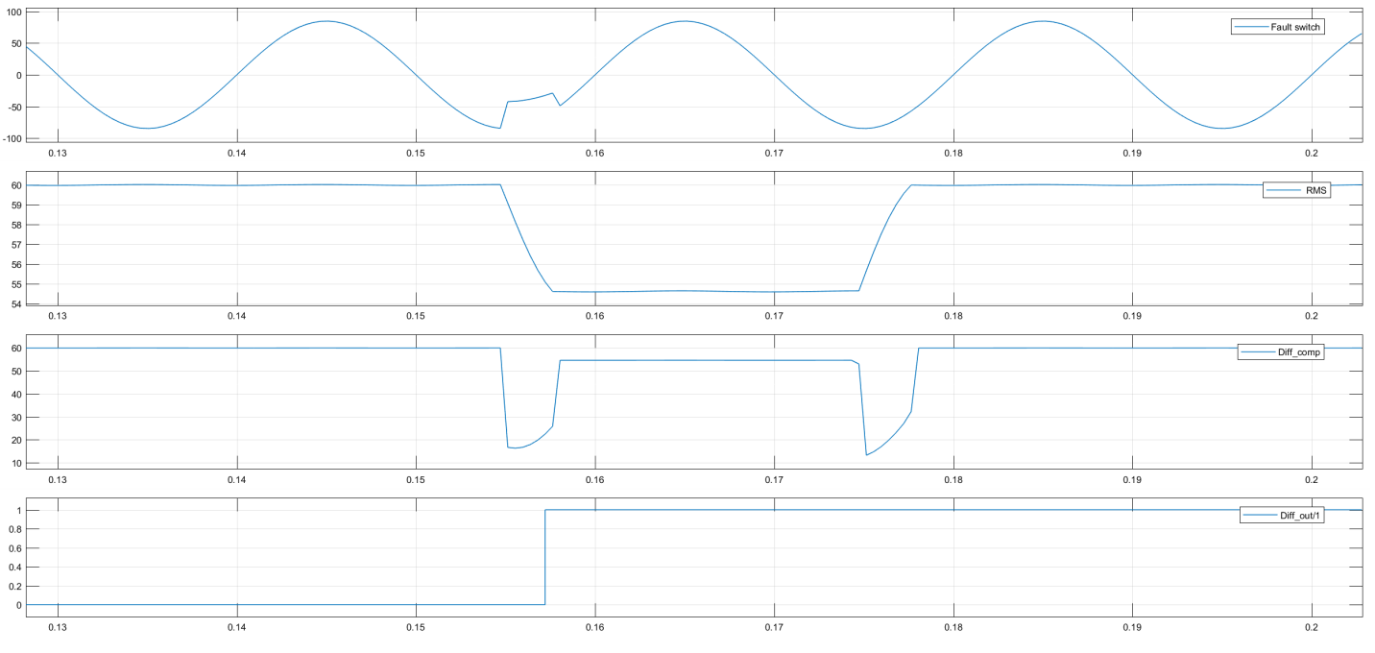
Figure 6. Simulation of a short-term voltage dip at the power supply input.
It can be seen from Fig. 6 that the 50% voltage dip with a duration of 3 ms, which occurred at the time moment t = 0.155 ms causes the voltage at the output of the integral type pickup unit to decrease to 54.6 V, whereas the voltage at the output of the integral-differential pickup unit decreases to 20 V, thereby allowing the emergency process onset to be detected in a clear-cut manner.
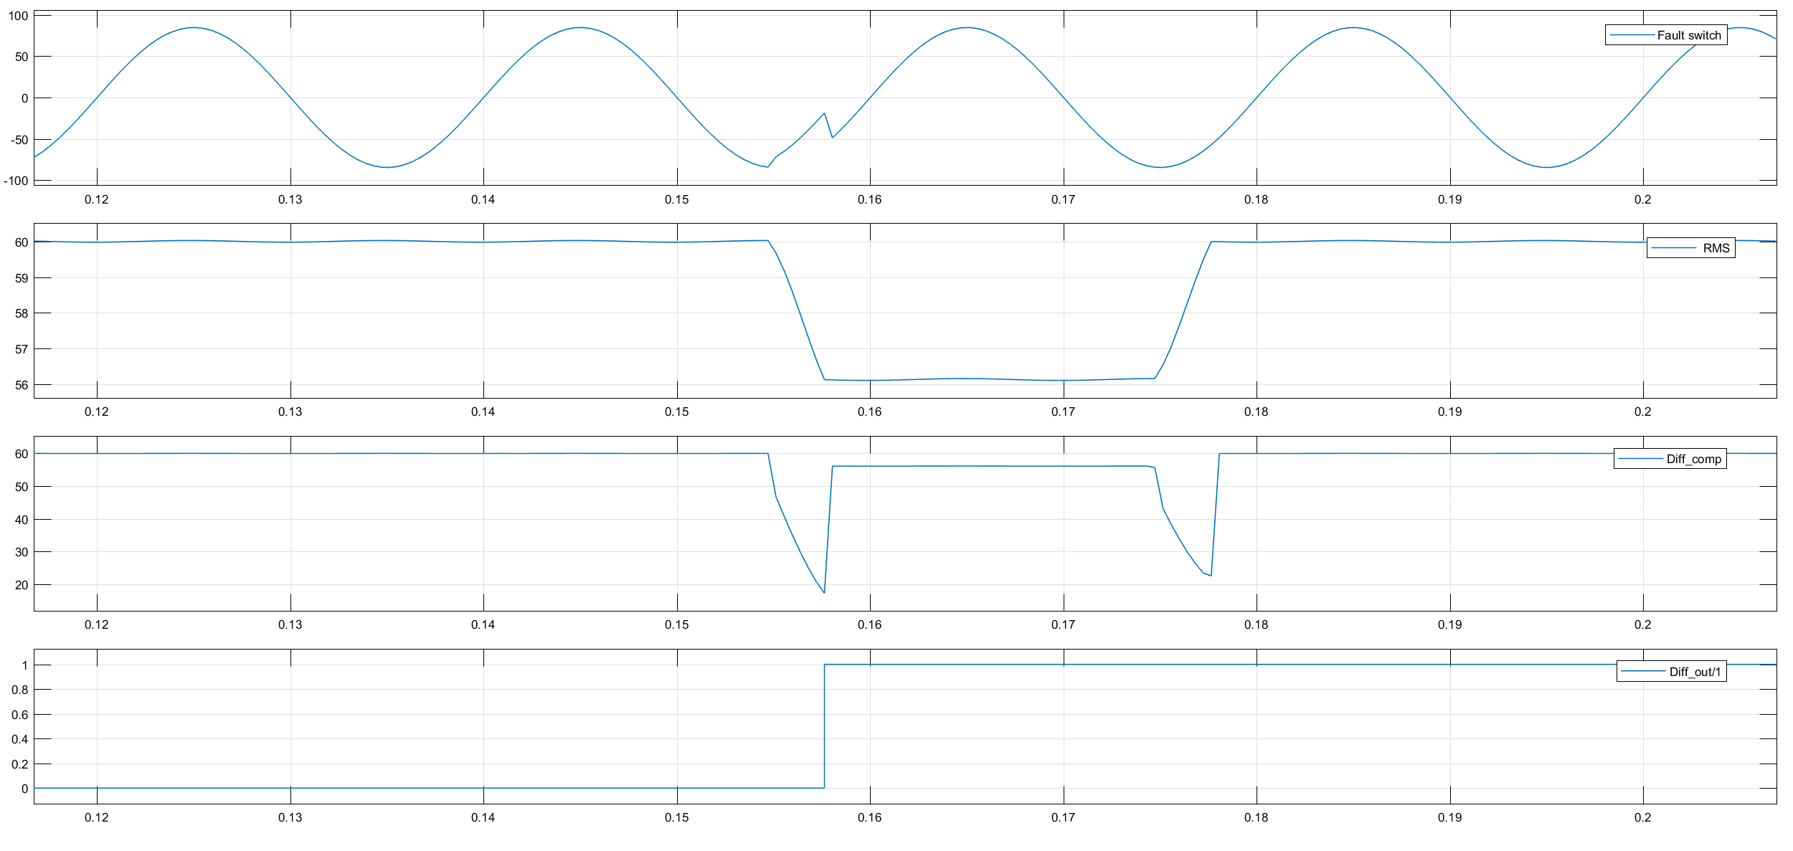
Figure 7. Simulation of a short-term phase shift at the power supply input.
In Fig. 7, a stepped change of the phase by 30° with a duration of 3 ms occurs at the time moment t = 0.155 ms, causing the voltage at the integral type pickup unit output to decrease to 56.2 V, whereas the voltage at the output of the integral-differential pickup unit decreased to 19.6 V, thereby also allowing the emergency process onset to be reliably detected.

- Conclusions
The key specific feature of the proposed pickup unit is the versatility of its operation algorithm, due to which it is able to analyze all potentially hazardous situations irrespectively of the load type and nature. Another advantage lies in the simplicity of its implementation, which does not involve the need to perform trigonometrical calculations of the current values of the phase angle δ and frequency F for detecting the emergency onset.
Further studies of methods for minimizing the operation time of emergency control devices like an HSBT seem to be advisable toward improving the design of switching apparatuses (circuit breakers) in terms of achieving their faster operation. Preference in this regard should be given to vacuum and SF₆ circuit breakers.
- References
[1] Gamazin S I, Stavtsev V A, Tsyruk S A Transients in industrial power supply systems triggered by electric motor load, A Monograph, MEI, 1997.
[2] Danilov N V, Tsyruk S A, Ryzhkova Ye N. Studying the power supply critical interruption time as a high-speed bus transfer success criterion. 2021 Int. Conf. on Industrial Engineering, Applications and Manufacturing (ICIEAM-2021). DOI: 10.1109/ICIEAM51226.2021.9446425
[3] Pupin V, Safonov D, Fedorov O Modeling and research of operating modes of oil and gas pumping stations to determine the requirements for automation devices. International Ural Conf. on Electrical Power Engineering, UralCon. 2020. 9216310. DOI: 10.1109/UralCon49858.2020.9216310.7
[4] Gandhare W Z, Jaonjare R S Protection of utility motors during switching. IEEE International Conference on Computer Communication and Control, IC4 2015. DOI: 10.1109/IC4.2015.7375618
[5] Gandhare W Z, Jaonjare R S Protection of utility motors during switching. 2015 Int. Conference on Computing, Communication and Security, ICCCS 2015. DOI: 10.1109/CCCS.2015.7374208
[6] https://new.siemens.com/global/en/products/energy/energy-automation-and-smart-grid/protection-relays-and-control/siprotec-4/high-speed-busbar-transfer-device/high-speed-busbar-transfer-siprotec-7vu68.html.
[7] Danilov N V, Danilov R N, Tsyruk S A, Gamazin, S I, Petrov V S RF Patent No. 2662639, “A method and device for implementing high-speed bus transfer”, 2018.
[8] Jwo D-J, Chang W-Y, Wu I-H Windowing techniques, the welch method for improvement of power spectrum estimation. 2021 Computers, Materials and Continua. 67(3), pp. 3983-4003
[9] Danilov N V, Tsyruk S A and Petrov V S RF Patent 2717236 “A method and device for implementing high-speed bus transfer”, 2020
[10] Zhmud V, Dimitrov L, Nosek J Effective algorithm to design pid-regulator by numerical optimization. international multi-conference on industrial engineering and modern technologies, FarEastCon 2020. DOI: 10.1109/FarEastCon50210.2020.9271402.
[11] Miller Y V, Sablina G V Calculation of PID-controller parameters (2020). Automatics & Software Enginery, 1 (31), pp. 148-153.
[12] ABB VM1 Installation and Service Instructions Manual. https://www.manualslib.com/manual/1335536/Abb-Vm1.html#manual
[13] IEC TR 61000-2-8:2002. Electromagnetic Compatibility (EMC) - Part 2-8: Environment - Voltage Dips and Short Interruptions on Public Electric Power Supply Systems with Statistical Measurement Rsults.
[14] Demiroren A, Zeynelgil H L Modelling and simulation of synchronous machine transient analysis using SIMULINK. Int. Journal of Electrical Engineering Education, 39 (4), 2002. pp. 337-346. DOI: 10.7227/IJEEE.39.4.

